Presentation and Visualization of Data

Michael Surdek

Southern New Hampshire University

I previously created visualizations for three separate audiences: today’s potential car buyers, a team of quality control workers, and a manufacturing company management team. I chose to create new visualizations by modifying visual cues on the visuals for today’s potential car buyers and the manufacturing company management team. These are the original charts:

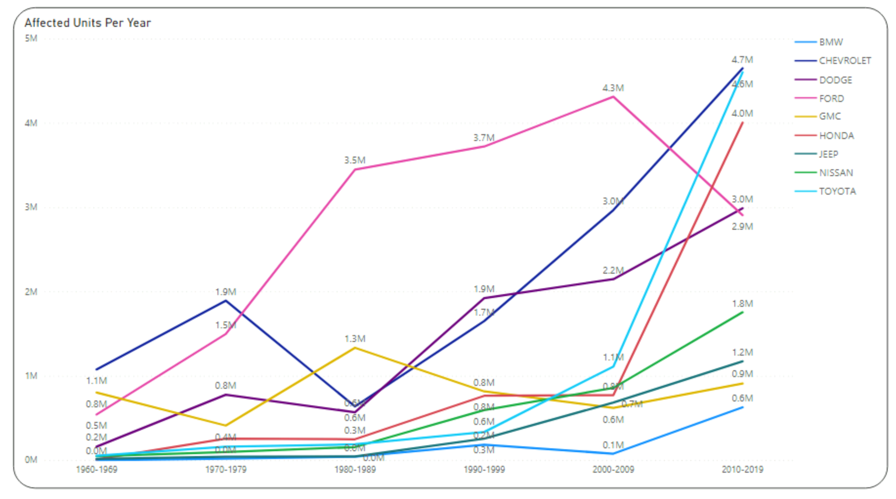

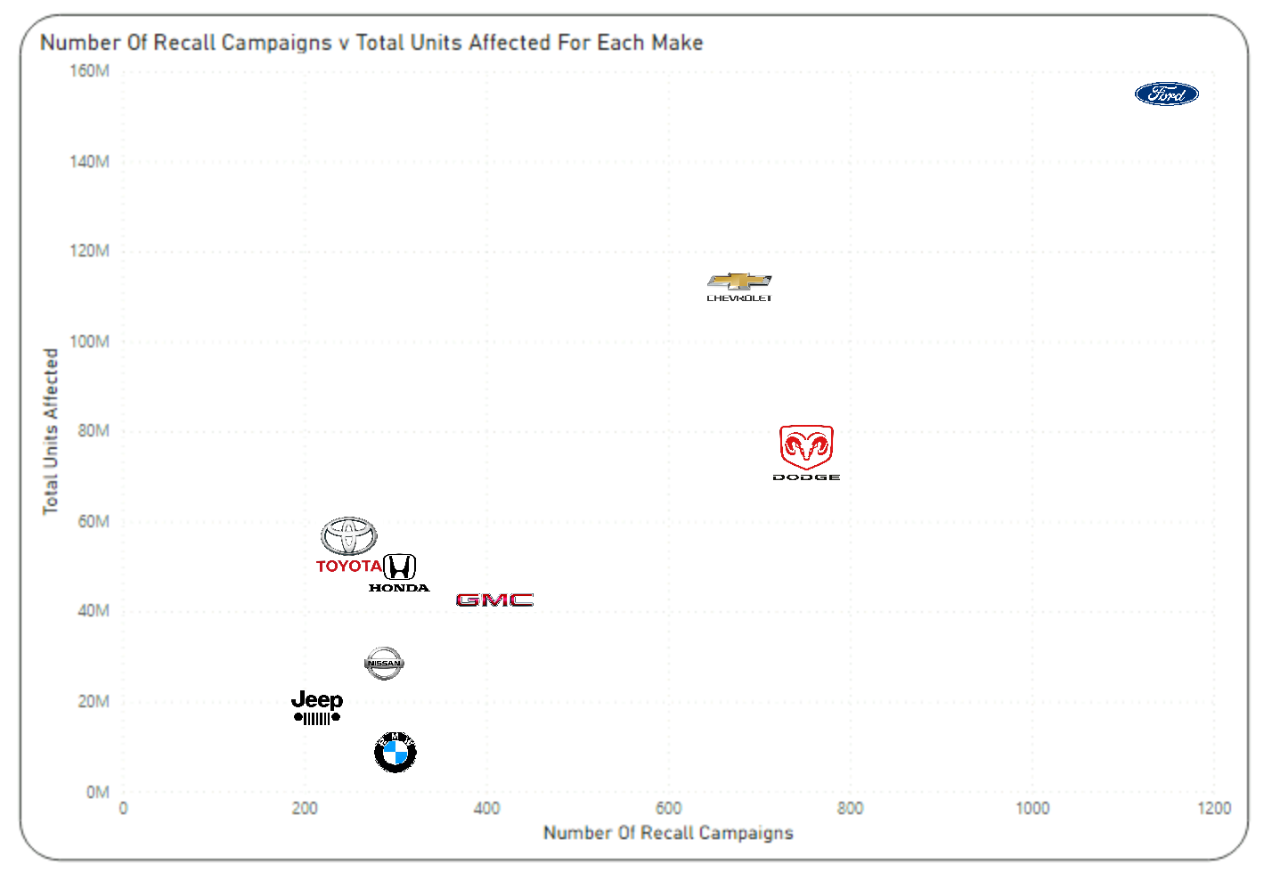

I utilized the position visual cue to modify the visual for potential car buyers by filtering 1960-1969 and 1970-1979 from the Decade field. This new visual shows lines moving over four decades instead of six. The use of this cue makes the chart more readable and emphasizes some of the significant variations in values. Since the audience would be more concerned about recent data and trends about the car makes, the modification to the position cue provides more relevant information and more clearly highlights the largest trends.

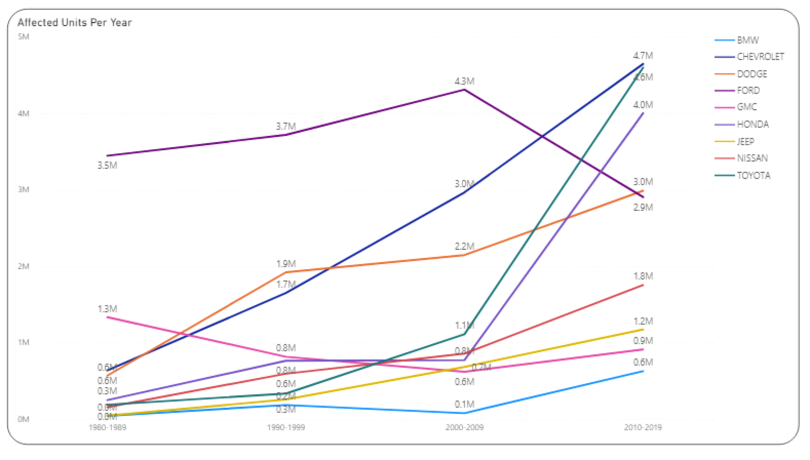

I utilized the shapes visual cue to modify the visual for potential car buyers by altering the line type shown and adding squares to each reference point on the data. The new visual allows the values of each make’s affected units per year and its changes over time to stick out more than the lines themselves, which can be harder to understand at first glance. The alteration of the line type from a solid line to a dashed line is meant to draw less attention to the lines and more attention to the points and how they change over time for each make. Adding squares instead of having the lines continue through each point is meant to more easily show the points along the lines that are being measured and where the rate of change along the line could vary, even if only slightly, e.g. Chevrolet in 2000-2009.

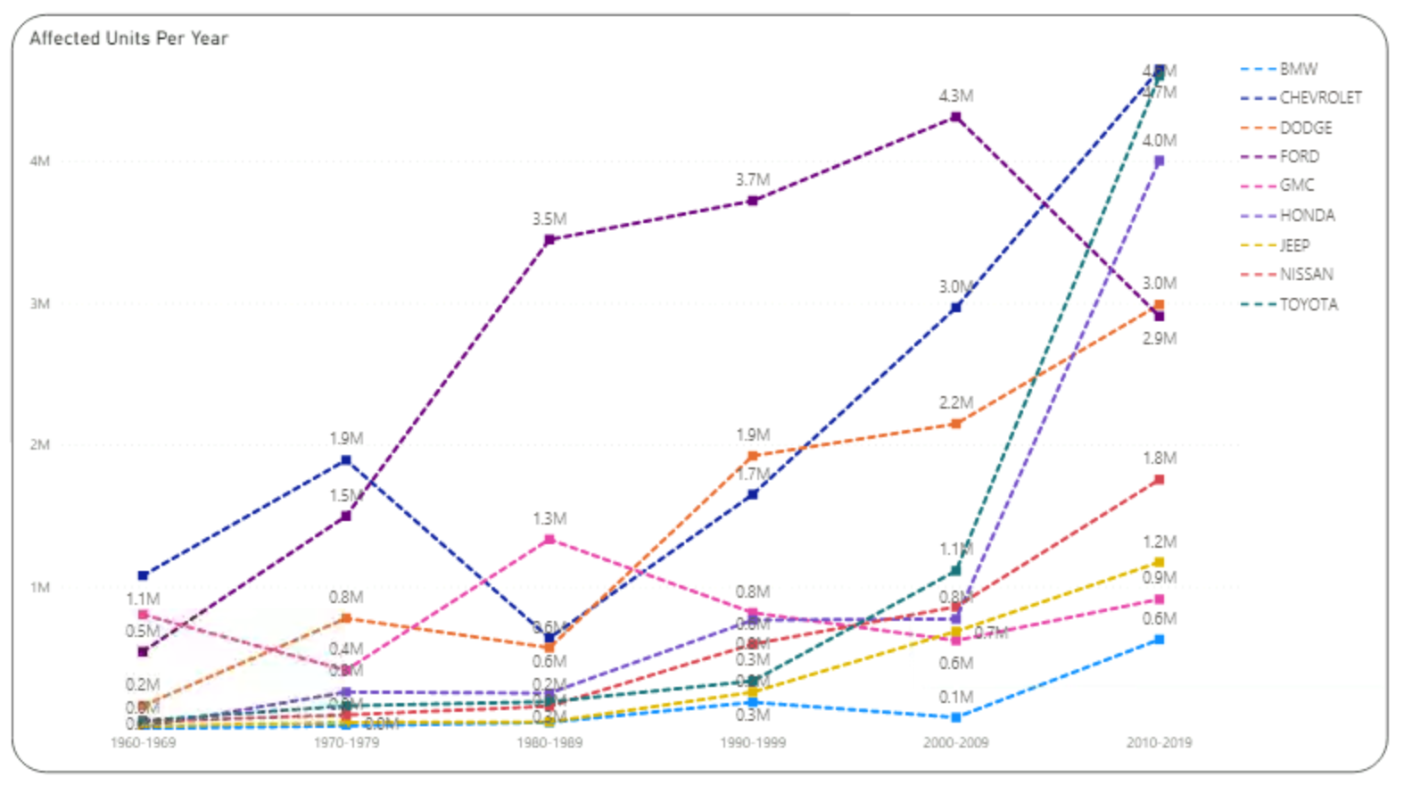

I utilized the color visual cue to modify the visual for potential car buyers by turning the background black and the text elements white, instead of vice versa. Since the lines on the original visualization are bright colors, they can be difficult to differentiate on a white background. Additionally, since there 9 car makes incorporated into the visual, there are multiple hues of both blue and purple. The black background makes it easier to tell the difference between these lines. The meaning of the visual does not change when the color visual cue is modified in this way. All of the information on the chart remains the same and is presented in a similar way. The purpose of modifying the color visual cue is just to make the visualization more friendly to the eye.

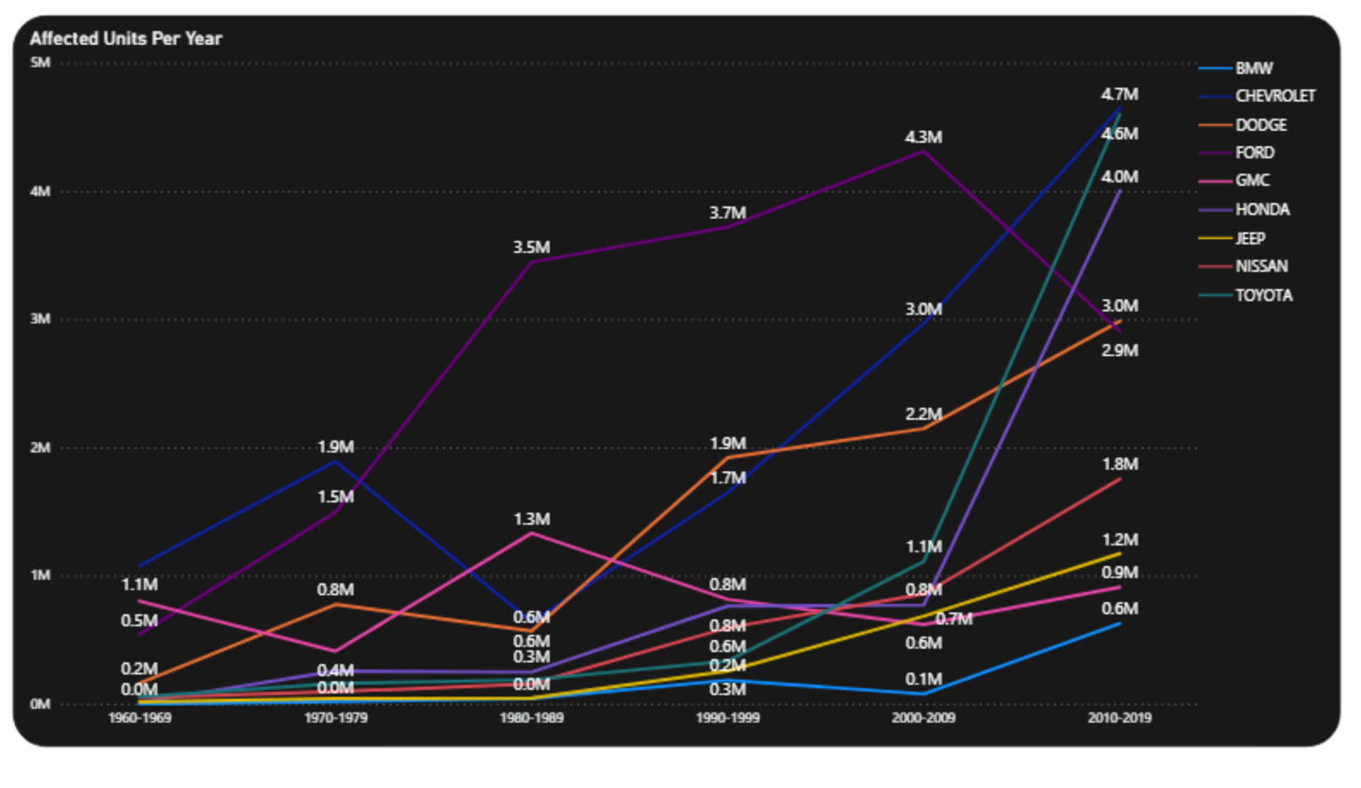

I utilized the position visual cue to modify the visual for the manufacturing company management team by adding a regression line to the chart. I mentioned in my breakdown on the last assignment that one of the takeaways of the visual would be to see which car makes tend to have more or fewer affected units per recall campaign. By adding the regression line, whose slope indicates the average number of affected units per recall campaign, the audience knows that data points below and to the right of the line have fewer than average affected units per recall campaign, and vice versa for data points above and to the left of the line. Instead of each data point logo being viewed in a position relative to the others, they are viewed in a position relative to the line. The management team can more easily interpret which car makes have the most and the least affected units for each of their recall campaigns.

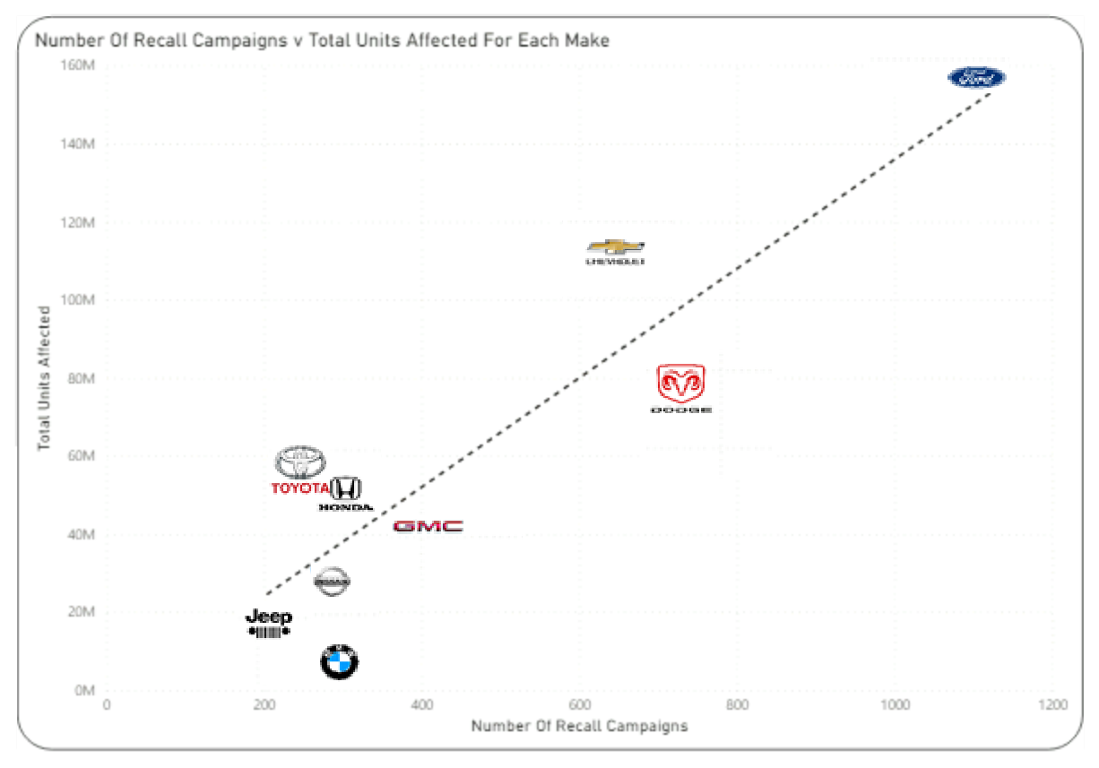

I utilized the shapes visual cue to modify the visual for the manufacturing company management team by using large blue circles as data points instead of the logos of each of the car makes. In my initial visualization, I originally produced a scatterplot with these blue data points and then added the logos in their place. This was in an attempt to improve the chart’s readability, since the management team would be familiar with each of the logos. The chart became simpler when I modify the shapes visual cue by reverting back to the blue data points, which can be a good thing for the audience if they are just trying to gather information without any bells and whistles. Once I had changed the shapes visual cue, I had to add labels to the data points, or else there would just be points on a scatterplot with no context. In my original visual, this context was handled by the logos.

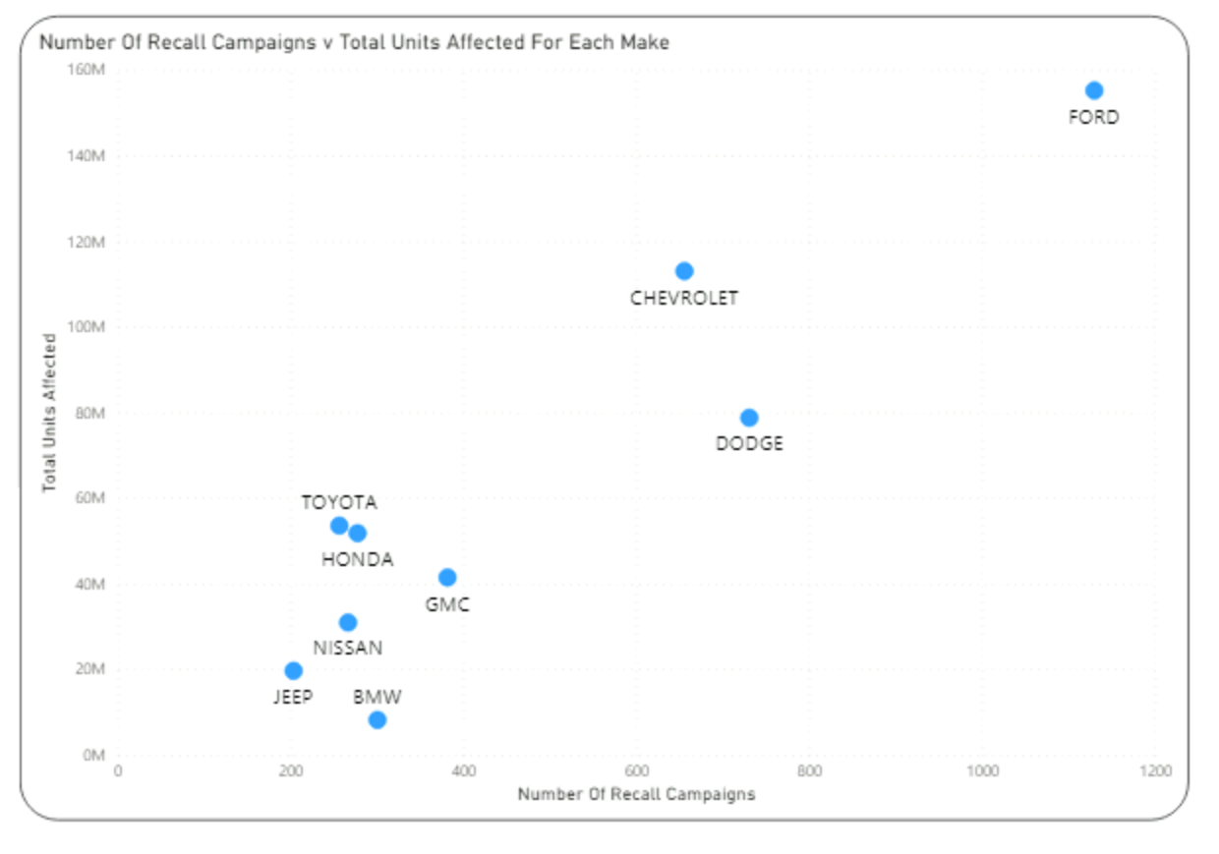

I utilized the color visual cue to modify the visual for the manufacturing company management team by using nine different colors for the data points instead of using light blue for them all. In the scatterplot above, the light blue points become redundant and do not jump off the page. However, using different colors for each point allows them to stick out more individually so that the audience can more easily interpret their position on the plot. This type of display impacts the meaning of the visualization by presenting the data points without any distractions. If the chart were going to be lingered on as an important piece of information, I would not utilize the color visual cue in this way, but if it were meant to be looked over briefly and easily interpreted, this could be the best method.

